Title of the Project
EVENT MANAGEMENT SYSTEM
ABSTRACT:
The event management system is an innovative solution designed to simplify and automate the planning, organization, and execution of events. Traditional methods of managing events often involve extensive manual coordination, leading to inefficiencies, errors, and increased workload for organizers. Challenges such as managing schedules, tracking attendees, and ensuring effective communication can hinder the success of events, especially those involving large audiences or complex logistics.
The proposed event management system integrates advanced web-based technologies to address these challenges by offering an all-in-one platform for event planning and management. Key features include event scheduling, real-time attendee registration, automated reminders, and resource allocation. The system also supports venue management, budget tracking, and vendor coordination, ensuring end-to-end management of all event components.
For user engagement, the system incorporates a dynamic event portal with personalized dashboards for participants, allowing them to access event schedules, receive updates, and provide feedback. Administrators benefit from a comprehensive control panel for monitoring event progress, analyzing participation metrics, and generating reports for future planning. Integration with communication tools and social media platforms ensures seamless communication and promotion.
This event management system is designed to enhance efficiency, reduce administrative overhead, and improve the overall experience for organizers and participants. Its scalability makes it suitable for managing diverse events, including corporate conferences, cultural programs, academic seminars, and social gatherings, ensuring smooth execution and increased attendee satisfaction.

Introduction
Event management is an essential aspect of modern-day organizational functions, spanning various industries such as corporate, academic, social, and cultural sectors. Traditionally, managing events has been a manual and time-consuming process, often resulting in inefficiencies, communication breakdowns, and missed opportunities for seamless execution. The complexities involved in event planning, such as coordinating multiple tasks, managing large audiences, tracking attendee registrations, ensuring resource availability, and handling logistics, can overwhelm organizers, especially when done manually. As the demand for larger, more dynamic events grows, traditional methods become increasingly inadequate.
In response to these challenges, the event management system aims to offer an automated, user-friendly platform that simplifies the planning, organization, and execution of events. This system integrates modern technologies like web-based tools, real-time communication, and data analytics, providing a comprehensive solution for managing all event-related tasks. The core functionalities of this system include event scheduling, attendee registration, automated reminders, resource allocation, budget tracking, and vendor management, offering a one-stop platform for event organizers.
With the rise of large-scale and virtual events, such systems have become critical to managing the complexities of modern-day event planning. The platform also enhances participant experience by offering personalized dashboards and engagement features, ensuring better interaction, feedback, and communication. Administrators benefit from detailed reporting and control panels that allow them to track event progress, monitor engagement, and improve future event planning strategies.
By automating key tasks and improving communication, the event management system optimizes efficiency, reduces administrative workload, and enhances the overall event experience, making it suitable for a wide range of events, from corporate conferences to social gatherings.

Background & Objectives
Managing events effectively requires timely information, seamless coordination among teams, and the ability to manage multiple aspects of an event simultaneously. Traditional event management methods, though effective in some cases, are often labor-intensive and prone to errors, especially in large-scale events with complex logistics. This background of inefficiency has highlighted the need for an automated solution that can simplify the process while maintaining accuracy and ease of use.
The primary objective of this project is to develop an event management system that integrates modern technologies to handle all aspects of event planning. This includes features for managing event schedules, handling registrations, facilitating real-time communication, and tracking attendee engagement. The system also aims to streamline coordination between organizers, vendors, and participants, providing a centralized platform that reduces manual workload and improves event execution.

Purpose, Scope, and Applicability

Purpose:
The primary purpose of this event management system is to provide a comprehensive solution that streamlines the entire process of event planning and execution. By automating scheduling, registration, communication, and resource management, the system aims to minimize errors, reduce workload, and increase efficiency. Additionally, it seeks to improve participant satisfaction by offering a personalized experience and ensuring smooth, seamless communication throughout the event lifecycle.

Scope:
This system covers a wide array of event management tasks, including event scheduling, real-time attendee registration, budget tracking, venue management, vendor coordination, and communication. The system is designed to handle both small and large-scale events, with features that scale to accommodate events of varying complexity. The platform also provides tools for tracking attendee engagement, collecting feedback, and generating reports for future event optimization.

Applicability:
The event management system is versatile and can be applied across different sectors such as corporate businesses, education institutions, cultural organizations, and social events. Whether it’s a small seminar, a large international conference, or a corporate training session, this system can be customized to fit the needs of different event types. Its scalability makes it suitable for a variety of industries, ensuring a smooth execution from start to finish.

Vision Statement
The vision of the event management system is to redefine the way events are planned and executed by providing an intelligent, easy-to-use platform that improves efficiency, reduces manual errors, and enhances the overall experience for both organizers and participants. Through automation, seamless integration with communication channels, and real-time data processing, the system aims to be the leading solution for modern event management, making events more successful, organized, and memorable.

Achievements
- Automation of Event Planning:
The system successfully automates various aspects of event planning, including scheduling, attendee registration, and resource allocation. This reduces the need for manual intervention and eliminates the risk of errors associated with traditional methods.
- Seamless User Experience:
By offering personalized dashboards for both participants and administrators, the system enhances user engagement and ensures that all parties have access to real-time event updates and relevant information.
- Real-Time Communication Integration:
Integration with communication tools and social media platforms enables continuous interaction and updates, enhancing collaboration between organizers, participants, and vendors.
- Scalability and Flexibility:
The system has been designed to handle events of varying sizes, from small meetings to large conferences, providing scalability and flexibility to meet the specific needs of different event types.
- Data-Driven Insights:
The comprehensive control panel for administrators allows for the tracking of attendance metrics, feedback collection, and report generation, providing actionable insights for future event planning.

Organization of Report
The report is structured as follows:
- Introduction
Overview of event management challenges and the motivation behind developing the system.
- Background & Objectives
Discussion on traditional event management limitations and the objectives of the project.
- Purpose, Scope, and Applicability
Explanation of the system's purpose, its scope of functionalities, and its applicability across different industries and event types.
- System Architecture and Design
Detailed explanation of the system architecture, key technologies used, and the design of the platform, including the user interface and backend.
- Features and Functionality
In-depth description of the key features of the event management system, including scheduling, registration, communication tools, and vendor management.
- Implementation
A detailed account of how the system was developed, including programming languages, frameworks, and integration techniques used.
- Evaluation and Testing
Results from the testing phase, showcasing the system's effectiveness in handling various event management tasks, and its user feedback.
- Conclusion
A summary of the project's success and its potential for improving event management processes.
- Future Work
Suggestions for system enhancements and future features to further improve the event management process.
- References
Citations of sources used for system development and related research.
- Appendices
Additional information such as code snippets, user manuals, or extended data from testing phases.

Existing System
The existing event management process primarily relies on manual methods or basic tools such as spreadsheets, emails, and paper-based registrations. These traditional approaches lead to difficulties in coordinating between event organizers, vendors, and participants. Managing schedules, attendee data, and communication becomes cumbersome and time-consuming. Additionally, there is no centralized system for tracking resources, budgets, and feedback, resulting in errors, duplication of data, and inefficiency in event execution.

Disadvantages of Existing System
- Manual coordination increases the risk of human error.
- Time-consuming process for event registration and scheduling.
- Lack of real-time updates and attendee tracking.
- Difficult to manage multiple events simultaneously.
- Inefficient communication between organizers, vendors, and participants.
- No analytical tools for post-event evaluation and reporting.

Proposed System
The proposed Event Management System is a web-based platform designed to automate and streamline the entire event lifecycle—from planning to execution and feedback collection. The system provides modules for event creation, registration, scheduling, communication, and reporting. Organizers can easily manage venues, track budgets, and allocate resources through an intuitive dashboard.
Participants can register online, receive instant confirmations, and get automated reminders about event updates. The system also integrates email notifications, vendor coordination, and feedback mechanisms to ensure smooth communication and continuous improvement. Moreover, administrators can monitor live event status, analyze participation trends, and generate performance reports for future planning.

Advantages of Proposed System
- Automated event planning reduces manual workload and errors.
- Real-time updates improve communication and coordination.
- Online registration and reminders enhance participant engagement.
- Centralized data management for easy access and control.
- Budget tracking and vendor management improve transparency.
- Scalable and adaptable for various types of events.
- Analytical reports help organizers evaluate event success and optimize future events.

Survey System Technology Stack:
- Frontend:
  - HTML: HTML (Hypertext Markup Language) is used to create the structure of the survey. It will include elements like input fields, checkboxes, radio buttons, and a submit button.
  - CSS: CSS (Cascading Style Sheets) is used for styling the survey form, including layouts, colors, fonts, and other visual elements, ensuring a clean and user-friendly design.
- Backend:
  - PHP: PHP (Hypertext Preprocessor) is used on the backend to handle the form submissions. It collects the responses from users, validates the input, and processes the data. The responses are stored in a database (e.g., MySQL or similar).
  - MySQL: MySQL is a relational database management system used to store the responses from users. The responses are saved in tables, where each survey submission is recorded with unique identifiers (e.g., respondent ID, timestamp) and answers.
- Survey Workflow:
  - Survey Form: The survey form is built using HTML and CSS, containing fields for different types of questions (e.g., text fields, multiple choice, radio buttons, dropdown menus).
  - Form Submission: When a user submits the survey, the form data is sent to the backend via the POST method.
  - Data Processing: PHP processes the submitted data. It validates the responses and stores them in the MySQL database.
  - Results Handling: Once the responses are stored, they can be displayed in a summary format (such as charts or tables) to the administrator or for future analysis. PHP can also be used to fetch, sort, and display the results from the database.
- Features of a Survey System:
  - User Interface: A clean and intuitive frontend that encourages users to complete the survey. This can include dynamic features such as interactive forms (e.g., conditional questions).
  - Data Validation: On the backend, validation ensures that the submitted data is correct and properly formatted (e.g., ensuring no empty responses, verifying email addresses).
  - Security: Protection against SQL injection and other security vulnerabilities is essential. This can be achieved by using prepared statements and sanitizing inputs.
  - Response Storage: All responses are stored in the database with details such as the time of submission. These responses can later be analyzed to derive insights.
  - Results Analysis: After the survey is completed, the system can generate reports based on the responses. These reports can be used for statistical analysis or to create visual representations like charts and graphs.
- Optional Enhancements:
  - User Authentication: Implementing a login system for users to track their progress and ensure that surveys are only completed once by each individual.
  - Email Notifications: Sending email confirmations to users upon survey submission or reminders to complete the survey.
  - Integration with Other Tools: You can integrate the survey system with communication tools or social media platforms for sharing the survey and promoting participation.
  - Real-time Feedback: Providing users with immediate feedback or thank-you messages after submitting the survey.
This survey technology stack enables the creation of a functional and secure survey system, allowing organizations to gather valuable feedback, perform analysis, and improve decision-making processes.

1. Problem Definition
Managing events manually involves numerous challenges such as miscommunication, schedule conflicts, attendee tracking difficulties, and inefficient resource allocation. Traditional methods require extensive paperwork, manual coordination, and repetitive tasks, increasing the risk of errors and inefficiencies. Organizers often struggle with real-time updates, budget management, and vendor coordination, leading to event mismanagement. The proposed Event Management System aims to resolve these issues by providing an automated, web-based platform that streamlines the planning, execution, and monitoring of events efficiently.

2. Requirements Specification

Functional Requirements:
- User registration and authentication for attendees and organizers.
- Event creation, scheduling, and management with customizable categories.
- Real-time attendee registration and confirmation system.
- Automated email and SMS reminders for event notifications.
- Venue selection and resource allocation system.
- Budget tracking and vendor management tools.
- Personalized dashboards for participants and organizers.
- Report generation and analytics for post-event evaluation.
- Integration with payment gateways for ticketing and bookings.
- Social media integration for event promotions.

Non-Functional Requirements:
- User-friendly interface with responsive design for multiple devices.
- Secure authentication system with encrypted transactions.
- Fast performance and optimized database queries.
- Scalability to handle different event types and user loads.
- Data backup and recovery mechanisms to prevent data loss.

3. Planning and Scheduling
The project will be completed in the following phases:
Phase | Tasks | Duration
Phase 1: Requirement Analysis | Identify functional and non-functional needs, stakeholder interviews | 2 Weeks
Phase 2: System Design | Define architecture, database schema, UI wireframes | 3 Weeks
Phase 3: Development | Implement front-end, back-end, and database integration | 5 Weeks
Phase 4: Testing | Unit testing, integration testing, and bug fixes | 3 Weeks
Phase 5: Deployment & Maintenance | Deploy system, collect user feedback, optimize performance | Ongoing

4. Software and Hardware Requirements

Software Requirements:
- Front-end: React.js / Angular / HTML, CSS, JavaScript
- Back-end: Node.js / Django / Spring Boot
- Database: MySQL / MongoDB
- Cloud Hosting: AWS / Firebase / DigitalOcean
- Communication APIs: Twilio / SMTP for email notifications

Hardware Requirements:
- Server: Cloud-based or on-premise server with high availability
- Minimum 8GB RAM and 500GB storage for database management
- User devices: Laptop, Desktop, Smartphone with an updated browser

5. Preliminary Product Description
The Event Management System is a web-based application designed to automate event planning and execution. It provides a centralized platform where organizers can create, manage, and promote events while allowing attendees to register, receive notifications, and participate seamlessly. The system enhances communication through integrated email and SMS alerts, while analytics tools offer insights into event performance. With secure authentication and payment gateways, users can confidently handle transactions and manage resources efficiently.

6. Conceptual Models

Use Case Diagram:
- Actors: Event Organizer, Attendee, Administrator
- Use Cases:
  - Organizer: Create event, set schedule, manage attendees, send notifications
  - Attendee: Register for event, receive alerts, provide feedback
  - Administrator: Monitor system performance, generate reports

ER Diagram (Entity-Relationship Diagram):
- Entities: Users, Events, Venues, Vendors, Payments, Reports
- Relationships:
  - One event can have multiple attendees
  - One organizer can manage multiple events
  - One event can have multiple vendors
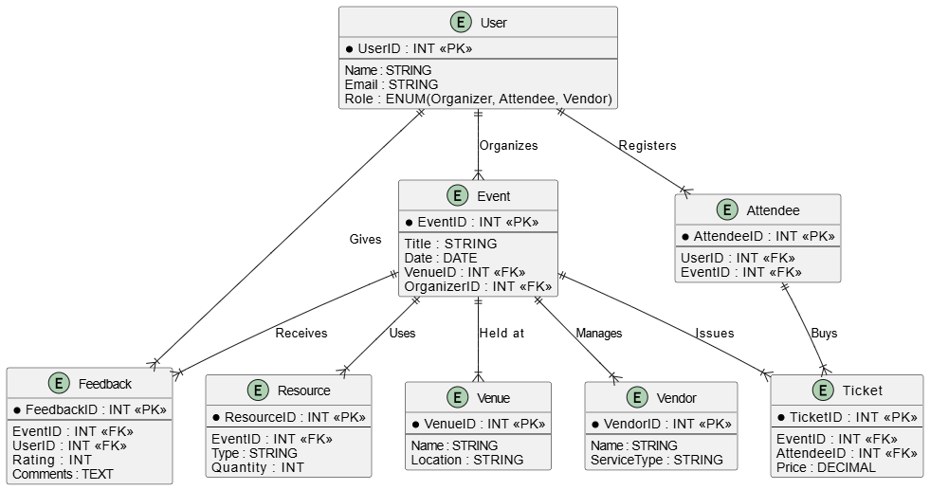

System Architecture:
- Client-Side: Users interact with the system via a web-based interface.
- Server-Side: Handles business logic, authentication, and database operations.
- Database Layer: Stores event details, user data, and payment records.
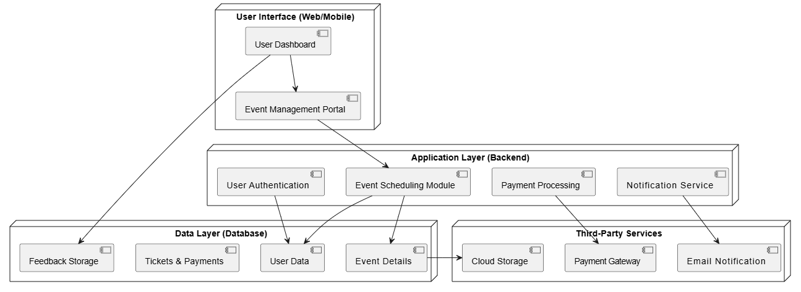

Chapter 4 & 5(System Design & Implementation and Testing)
Basic Modules
• User Management Module
- User registration and login (Attendees, Organizers, Vendors)
- Role-based access control (Admin, Event Manager, Attendee)
- Profile management and customization
• Event Planning & Scheduling Module
- Event creation and categorization (Corporate, Academic, Cultural, etc.)
- Scheduling and timeline management
- Venue selection and booking
• Attendee Registration & Ticketing Module
- Online attendee registration and ticket booking
- QR code or digital ticket generation
- Payment integration for ticket sales
• Communication & Notification Module
- Email and SMS notifications for event updates
- Automated reminders for attendees and organizers
- Integration with social media for event promotion
• Resource & Budget Management Module
- Allocation of resources (venue, equipment, catering, etc.)
- Budget planning and expense tracking
- Vendor management and contract handling
• Real-Time Monitoring & Feedback Module
- Live event tracking (attendance, session progress)
- Post-event feedback collection and analysis
- Report generation for future event planning
• Dashboard & Analytics Module
- Personalized dashboard for organizers and attendees
- Event insights and participation metrics
- Data visualization and exportable reports
• Security & Compliance Module
- Data encryption and user authentication
- GDPR and privacy compliance
- Backup and recovery system

Data Design
The data design of the event management system focuses on structuring and organizing data efficiently to support various functionalities. The system includes key entities such as Users, Events, Venues, Attendees, Tickets, and Vendors, each linked through relational database models. A User can have different roles (Organizer, Attendee, or Vendor) and interact with multiple events. Event details, including schedule, location, and resources, are stored with proper indexing for fast retrieval. The Attendee Registration process maintains a list of participants, while the Ticketing system manages ticket sales and validation. The system ensures data integrity and security using encryption and access control mechanisms. Relationships between entities are managed through foreign key constraints, ensuring consistency. The database is designed for scalability, allowing support for large events with multiple concurrent users.
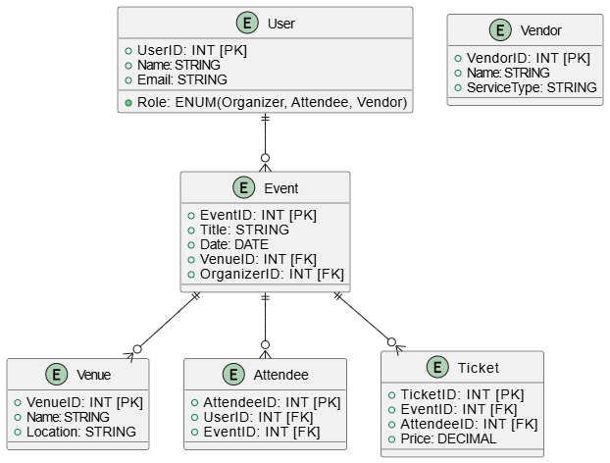
Procedural Design
The procedural design outlines the step-by-step execution flow of different system processes, ensuring logical sequence and efficient event management. When an Organizer creates an event, the system captures all details, including venue, date, and available resources. The Attendee registration process checks for ticket availability, processes payment, and assigns a QR-based ticket. The event scheduling process ensures there are no conflicts in timing or location. The notification system automates reminders via email and SMS to attendees and vendors. During the event, the system allows real-time tracking of attendee check-ins. After the event, feedback is collected and stored for analysis. Each procedure is modular, ensuring maintainability and scalability for future enhancements.
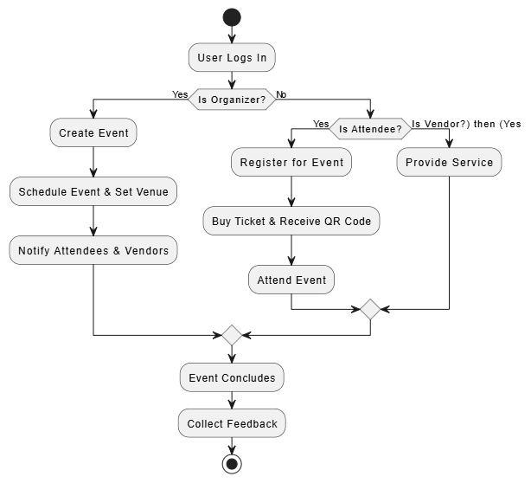
User interface design
The user interface design ensures an intuitive and user-friendly experience across different roles—organizers, attendees, and vendors. The homepage provides an overview of upcoming events, with filters for searching events by category, location, or date. Organizers have a dedicated dashboard for creating events, managing attendees, and tracking progress. Attendees can register, purchase tickets, and receive event notifications through their personalized interface. The event page displays all essential details, including venue, agenda, and guest speakers. The system supports a responsive design, ensuring seamless experience across devices. Interactive elements such as QR code scanning, real-time updates, and feedback forms enhance user engagement. The UI follows a minimalist and modern design approach, with a focus on accessibility and usability.
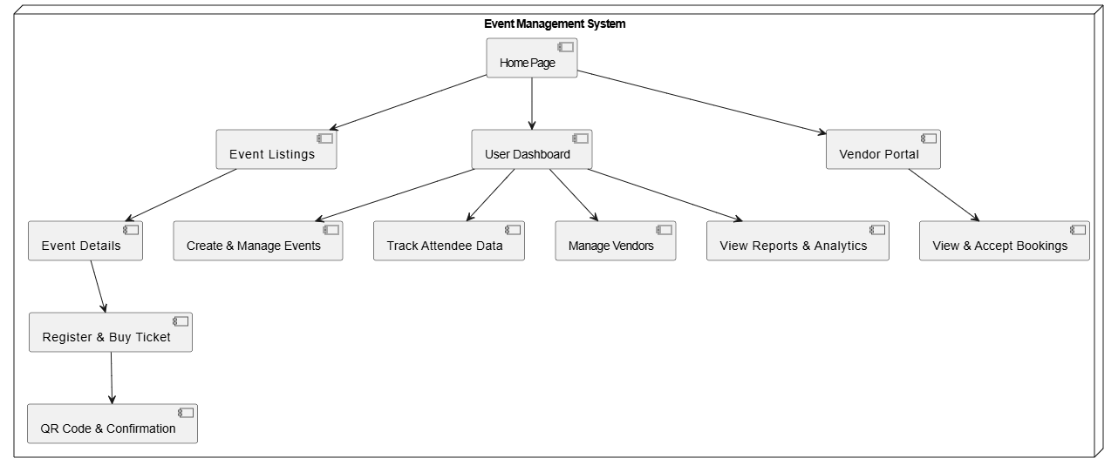
Risk List
Implementing an Event Management System comes with various risks that need to be identified and mitigated to ensure smooth operation. Security vulnerabilities pose a significant risk, as the system stores sensitive user information, including personal details, payment information, and event data. Without proper encryption and authentication mechanisms, unauthorized access or data breaches can occur. System downtime and performance issues are another risk, especially during high-traffic periods when users register for large events. If the system is not optimized for scalability, it may crash, leading to a poor user experience. Data integrity and loss can also be a major concern, especially if the database is not backed up regularly or if there are inconsistencies in event-related information. Without proper validation mechanisms, data duplication or corruption may occur, affecting decision-making and reporting. Cyber threats and hacking attempts such as phishing, DDoS attacks, or malware infections can disrupt the system’s functionality and compromise user information. Implementing firewalls, intrusion detection systems, and frequent security audits are necessary to mitigate these risks. User-related risks, such as unauthorized access by employees or misuse of admin privileges, can lead to fraudulent activities. Role-based access control (RBAC) must be enforced to restrict access to sensitive data based on user roles. Integration risks with third-party services, including payment gateways, email notification systems, and cloud storage, may arise due to compatibility issues, API failures, or service outages, which could disrupt financial transactions and communication. Legal and compliance risks must also be considered, as failure to adhere to data protection laws (e.g., GDPR, CCPA) could lead to penalties or legal actions. User adoption and technical challenges may occur if stakeholders, such as event organizers or attendees, find the system difficult to use. Proper training, documentation, and user-friendly interfaces can help overcome resistance to change. Financial risks related to budget overruns in development, maintenance, or cloud hosting fees should also be assessed to avoid unexpected costs. Technical dependency risks arise when relying heavily on a particular technology stack or service provider; if the provider discontinues support, it could lead to operational disruptions. Natural and environmental risks, such as server failures due to power outages, earthquakes, or floods, should also be considered, and disaster recovery plans should be in place. By proactively identifying and mitigating these risks through risk management strategies, robust security measures, efficient system architecture, and contingency planning, the Event Management System can ensure seamless event planning,
Test Cases Design
The Test Cases Design for the Event Management System ensures that all functional and non-functional aspects of the system are verified. User authentication testing is crucial to validate secure login, role-based access, and session management. Event creation and management testing checks whether event organizers can create, edit, delete, and update event details successfully. Attendee registration and payment processing tests ensure that users can register for events, make payments, and receive confirmation notifications. System performance testing is conducted to analyze how the system handles high traffic loads during peak event registration periods. Integration testing is performed to validate seamless communication between the application and third-party services such as payment gateways and email notifications. Usability and UI testing focus on verifying the user experience, ensuring that all buttons, menus, and forms work intuitively. Lastly, security testing is conducted to identify vulnerabilities, such as SQL injection, cross-site scripting (XSS), and data encryption flaws, to protect user data from cyber threats.
Implementation Approaches
The implementation of an Event Management System requires a structured approach to ensure scalability, efficiency, and robustness. The first approach is the modular development strategy, where the system is divided into key functional modules such as user authentication, event scheduling, payment processing, attendee registration, and reporting. Each module is developed independently and integrated using APIs to maintain flexibility. The second approach is the agile methodology, allowing for iterative development with continuous testing and feedback, ensuring that features can be modified based on user requirements. The third approach involves selecting an appropriate technology stack, including a frontend framework (React.js or Angular for a dynamic UI), a backend framework (Node.js with Express.js or Django for efficient data handling), and a database (MongoDB for NoSQL flexibility or MySQL for structured relational data). The fourth approach is cloud-based deployment, leveraging AWS, Azure, or Google Cloud for scalability, ensuring high availability and load balancing for large-scale events. The fifth approach is API-first development, ensuring seamless integration with third-party services such as payment gateways (Stripe, PayPal), email notification services, and social media platforms. The sixth approach focuses on security best practices, implementing OAuth 2.0 authentication, role-based access control (RBAC), and encrypted transactions to prevent data breaches. Lastly, microservices architecture can be implemented to ensure better scalability and maintainability, allowing each feature to function independently, improving system reliability and reducing downtime risks. These approaches together create a highly efficient, secure, and scalable Event Management System, ensuring seamless event planning and execution.

Coding Details and Code Efficiency
The efficiency of the code in an Event Management System is essential for ensuring fast execution, minimal resource usage, and seamless scalability. The backend should be optimized using asynchronous processing (Node.js with async/await) to handle concurrent requests efficiently, reducing latency in event registrations and payment processing. Database optimization is crucial; using indexing in SQL databases (e.g., MySQL) or proper document structuring in NoSQL databases (e.g., MongoDB) speeds up queries and prevents bottlenecks. Implementing caching mechanisms such as Redis for frequently accessed data (like event details) reduces load times and improves response speed. Efficient API design is key to minimizing data transfer—using RESTful APIs with JSON responses or GraphQL for selective data fetching can prevent over-fetching of unnecessary details. Code reusability and modularization are maintained using object-oriented principles and reusable components in frontend frameworks (React.js components or Angular directives). The frontend performance is enhanced by minimizing JavaScript bundle sizes using tree-shaking and lazy loading to improve page load speed. CSS frameworks like Tailwind CSS or Bootstrap help create lightweight and responsive UI designs. Implementing logging and debugging techniques such as Winston (for Node.js) or ELK Stack (for full-stack monitoring) helps track errors and optimize system performance. The use of CI/CD pipelines (Jenkins, GitHub Actions) ensures continuous deployment without system downtime, allowing rapid updates and bug fixes. By following these best practices, the system maintains high efficiency, performance, and maintainability, ensuring a smooth user experience.

Testing Approach
A comprehensive testing approach ensures that the Event Management System functions correctly under various conditions, identifying vulnerabilities and performance issues before deployment. The first step is unit testing, where individual functions and modules (e.g., event creation, user authentication, and ticket booking) are tested separately using frameworks like Jest (for JavaScript) or PyTest (for Python). The second step is integration testing, verifying interactions between different system components, such as database connectivity, API responses, and third-party services (e.g., payment gateway integration). The third step involves functional testing, where testers ensure that all system functionalities—like user registration, email notifications, and event scheduling—work according to requirements. The fourth step is performance testing, which includes load testing (analyzing system behavior under heavy traffic), stress testing (testing system resilience under extreme conditions), and scalability testing (ensuring the system can handle increasing users and events efficiently). The fifth step is security testing, which includes penetration testing (identifying security vulnerabilities like SQL injection, XSS attacks, and unauthorized access) and data encryption validation. The sixth step is usability testing, focusing on the user experience, ensuring a responsive UI, and verifying that event organizers and attendees can navigate the system effortlessly. The final step is acceptance testing, where end-users (event organizers and participants) interact with the system to confirm that it meets business requirements before deployment. Automated testing tools like Selenium (for UI testing) and Postman (for API testing) further improve efficiency. A well-planned testing approach enhances system reliability, security, and user satisfaction, ensuring a bug-free and robust Event Management System.

Modifications and Improvements
To enhance the Event Management System, various modifications and improvements can be implemented based on feedback and evolving requirements. First, AI-driven analytics can be integrated to provide personalized event recommendations based on user preferences, improving engagement and attendance. Second, chatbot integration using NLP-powered AI assistants can provide instant support for attendees and organizers, reducing manual intervention. Third, blockchain-based ticketing can enhance security and prevent fraud by ensuring tamper-proof ticket validation. Fourth, advanced event marketing automation can be integrated, allowing scheduled social media promotions, email campaigns, and personalized notifications. Fifth, voice-enabled commands can be added for accessibility, allowing users to perform tasks like event search and registration using voice assistants like Alexa or Google Assistant. Sixth, progressive web app (PWA) support can be introduced, ensuring that users can access event information seamlessly on mobile devices even in low-network conditions. Seventh, augmented reality (AR) features can be integrated to provide immersive virtual event experiences, allowing remote attendees to interact with events in real-time. Eighth, multi-language support can be added to ensure global accessibility for diverse audiences. Ninth, dynamic pricing models for tickets based on demand analytics can optimize revenue for organizers. Tenth, serverless computing can be implemented for cost-efficient cloud hosting, reducing infrastructure costs while ensuring high scalability. These modifications and improvements ensure that the system remains future-ready, user-friendly, and technologically advanced, enhancing the overall event management experience for organizers and attendees.
Chapter- 6 (Results and Discussion & Conclusion)
Test Reports
User Documentation
Conclusion
The Event Management System is a transformative solution that revolutionizes the way events are planned, organized, and executed. By integrating web-based technologies, the system automates various event management tasks, reducing the burden on organizers and ensuring seamless event execution. Its modular architecture enhances flexibility, allowing different stakeholders—including event organizers, participants, vendors, and sponsors—to interact efficiently. The system streamlines event scheduling, attendee registration, vendor coordination, venue management, and financial tracking, making it an all-in-one solution for diverse events such as corporate conferences, academic seminars, social gatherings, and cultural programs. The inclusion of real-time notifications, analytics, and personalized dashboards ensures that users remain informed and engaged. Furthermore, security measures such as encrypted transactions, role-based access control, and data integrity protocols safeguard sensitive event information. With cloud-based deployment, the system achieves high availability and scalability, accommodating a growing number of users without performance issues. By leveraging automation, real-time communication, and advanced data analytics, the Event Management System significantly enhances efficiency, minimizes errors, and improves the overall event experience. Despite certain challenges, this system lays a strong foundation for modern event management and has the potential to evolve further with advancements in AI, blockchain, and AR technologies.

Limitations of the System
While the Event Management System offers several advantages, it is not without limitations. One of the primary constraints is its dependence on internet connectivity, meaning that offline accessibility is limited, which can be a challenge in areas with poor network coverage. Another limitation is scalability concerns for large-scale events, where an extremely high number of attendees may lead to slow system performance if the backend is not optimized for heavy loads. Additionally, data security and privacy remain a challenge, especially for financial transactions, attendee personal information, and vendor contracts—any security loophole could lead to data breaches or fraud. The learning curve for non-technical users may also be a barrier, as event organizers and participants unfamiliar with digital platforms might struggle with system navigation. Another constraint is third-party dependency, where the system relies on external services such as payment gateways, email notification providers, and cloud hosting platforms, increasing the risk of operational failures if any of these services experience downtime. Customization limitations can also arise, as the system may not be flexible enough to cater to highly unique or industry-specific event requirements. Lastly, initial development and implementation costs may be a concern for small organizations with limited budgets, particularly if they require premium cloud services or extensive third-party integrations. Addressing these limitations will require continuous improvements and alternative solutions such as offline mode support, enhanced AI-driven automation, and stronger cybersecurity measures.
PHP:-
Introduction
PHP is now officially known as “PHP: Hypertext Preprocessor”. It is a server-side scripting language usually written in an HTML context. Unlike an ordinary HTML page, a PHP script is not sent directly to a client by the server; instead, it is parsed by the PHP binary or module, which is server-side installed. HTML elements in the script are left alone, but PHP code is interpreted and executed. PHP code in a script can query databases, create images, read and write files, talk to remote servers – the possibilities is endless. The output from PHP code is combined with the HTML in the script and the result sent to the user’s web-browser, therefore it can never tell the user whether the web-server uses PHP or not, because the entire browser sees is HTML.
PHP’s support for Apache and MySQL further increases its popularity. Apache is now the most-used web-server in the world, and PHP can be compiled as an Apache module. MySQL is a powerful free SQL database, and PHP provides a comprehensive set of functions for working with it. The combination of Apache, MySQL and PHP is all but unbeatable.
That doesn’t mean that PHP cannot work in other environments or with other tools. In fact, PHP supports an extensive list of databases and web-servers. While in the mid-1990s it was ok to build sites, even relatively large sites, with hundreds of individual hard-coded HTML pages, today’s webmasters are making the most of the power of databases to manage their content more effectively and to personalize their sites according to individual user preferences.
Reasons for using PHP
There are some indisputable great reasons to work with PHP. As an open source product, PHP is well supported by a talented production team and a committed user community. Furthermore, PHP can be run on all the major operating systems with most servers.

- Learning PHP is easy
Basic is easy any interpreted language should be easy to learn. Since you are isolated from the system (no pointers to use, no memory to allocate). The other advantage that all modern interpreted languages share is good associative array constructs.

- Its Performance
While we can build an application that serves millions of pages a day on a server, when we really look at the performance of the language it sucks. We are still orders of magnitude from real performance. Not only that, but since PHP is designed around a single process model our ability to share data structures or connection pool resources is left to native code libraries.

- The low cost
There are many languages which are available at very less cost. There are some languages which are available at very less cost like below:

- PHP
- C
- C++ etc

- It’s Open Source, We can modify it

We can modify it if you need a hole in your head! Technically the point is that it’s an open source project and they release patches often.

- Its Portability
C is portable; it’s just the OS bits that aren’t. A lot PHP isn’t portable to Windows since people don’t use the OS abstractions to avoid some problems.

- It has interfaces to a large variety of database systems
PHP supports a large variety of the database.
Support available
Online Support is available for using PHP.

d) PHP Syntax
You cannot view the PHP source code by selecting “View source” in the browser – you will only see the output from the PHP file, which is plain HTML. This is because the scripts are executed on the server before the result is sent back to the browser.

Basic PHP Syntax
A PHP scripting block always starts with <?php and ends with ?>. A PHP scripting block can be placed anywhere in the document.On servers with shorthand support enabled you can start a scripting block with <? And end with ?>. However, for maximum compatibility, we recommend that you use the standard form (<?php) rather than the shorthand form.

A PHP file normally contains HTML tags, just like an HTML file, and some PHP scripting code.

- HTML
HTML or Hyper Text Markup Language is the standard markup language used to create web pages. HTML was created in 1991 by Tim Berners-Lee at CERN in Switzerland. It was designed to allow scientists to display and share their research.
HTML is written in the form of HTML elements consisting of tags enclosed in angle brackets(like <html>). HTML tags most commonly come in pairs like <h1> and </h1>, although some tags represent empty elements and so are unpaired, for example <img>. The first tag in a pair is the start tag, and the second tag is the end tag (they are also called opening tags and closing tags).
The purpose of a web browser is to read HTML documents and compose them into visible or audible web pages. The browser does not display the HTML tags, but uses the tags to interpret the content of the page. HTML describes the structure of a website semantically along with cues for presentation, making it a markup language rather than a programming language.
HTML elements form the building blocks of all websites.
HTML allows images and objects to be embedded and can be used to create interactive forms. It provides a means to create structured documents by denoting structural semantics for text such as headings, paragraphs, lists, links, quotes and other items. It can embed scripts written in languages such as Java Script which affect the behavior of HTML web pages.
HTML is descriptive markup language. Library of various markup languages is defined in various browsers.

- HTML Images - The <img> Tag and the Src Attribute

In HTML, images are defined with the <img> tag.
The <img> tag is empty, which means that it contains attributes only, and has no closing tag.
To display an image on a page, you need to use the src attribute. Src stands for "source". The value of the src attribute is the URL of the image you want to display.
Syntax for defining an image:
<imgsrc="url" alt="some_text">

- HTML FORMS

HTML forms are used to pass data to a server.
An HTML form can contain input elements like text fields, checkboxes, radio-buttons, submit buttons and more. A form can also contain select lists, textarea, fieldset, legend, and label elements.

- Image tag (<img>) :
To add an image to an HTML document, we just need to include an <IMG> tag with a reference to the desired image. The <IMG> tag is an empty element i.e. it doesn’t require a closing tag and we can use it to include from small icons to large images.
Syntax: <imgsrc=”URL” alt=”alternative text”>

- HTML Lists :

An ordered list:  - The first list item  - The second list item  - The third list item | An unordered list:  - List item  - List item  - List item
HTML 5
HTML5 will be the new standard for HTML. The previous version of HTML, HTML 4.01, came in 1999. The web has changed a lot since then. HTML5 is still a work in progress.
However, the major browsers support many of the new HTML5 elements and APIs. HTML5 is cooperation between the World Wide Web Consortium (W3C) and the Web Hypertext Application Technology Working Group (WHATWG). WHATWG was working with web forms and applications, and W3C was working with XHTML 2.0. In 2006, they decided to cooperate and create a new version of HTML. Some rules for HTML5 were established:
- New features should be based on HTML, CSS, DOM, and JavaScript
- Reduce the need for external plug-ins (like Flash)
- Better error handling
- More markup to replace scripting
- HTML5 should be device independent

- The development process should be visible to the public
CSS
CSS tutorial or CSS 3 tutorial provides basic and advanced concepts of CSS technology. Our CSS tutorial is developed for beginners and professionals. The major points of CSS are given below:

- CSS stands for Cascading Style Sheet.
- CSS is used to design HTML tags.
- CSS is a widely used language on the web.
- HTML, CSS and JavaScript are used for web designing. It helps the web designers to apply style on HTML tags.
Cascading Style Sheets (CSS) is a style sheet language used for describing the look and formatting of a document written in a markup language. While most often used to style web pages and user interfaces written in HTML and XHTML, the language can be applied to any kind of XML document, including plain XML, SVG and XUL. CSS is a cornerstone specification of the web and almost all web pages use CSS style sheets to describe their presentation.
CSS is designed primarily to enable the separation of document content from document presentation, including elements such as the layout, colors, and fonts. This separation can improve content accessibility, provide more flexibility and control in the specification of presentation characteristics.
CSS can also allow the same markup page to be presented in different styles for different rendering methods, such as on-screen, in print, by voice (when read out by a speech-based browser or screen reader) and on Braille-based, tactile devices.
It can also be used to allow the web page to display differently depending on the screen size or device on which it is being viewed. While the author of a document typically links that document to a CSS file, readers can use a different style sheet, perhaps one on their own computer, to override the one the author has specified.
With plain HTML you define the colors and sizes of text and tables throughout your pages. If you want to change a certain element you will therefore have to work your way through the document and change it. With CSS you define the colors and sizes in "styles". Then as you write your documents you refer to the styles. Therefore: if you change a certain style it will change the look of your entire site. Another big advantage is that CSS offers much more detailed attributes than plain HTML for defining the look and feel of your site.

- JAVASCRIPT
JavaScript (JS) is a dynamic computer programming language. It is most commonly used as part of web browsers, whose implementations allow client-side scripts to interact with the user, control the browser, communicate asynchronously, and alter the document content that is displayed. It is also being used in server-side network programming (with Node.js), game development and the creation of desktop and mobile applications.
JavaScript is a prototype-based scripting language with dynamic typing and has first-class functions. Its syntax was influenced by C. JavaScript copies many names and naming conventions from Java, but the two languages are otherwise unrelated and have very different semantics. The key design principles within JavaScript are taken from the Self and Scheme programming languages. It is a multi-paradigm language, supporting object-oriented, imperative, and functional programming styles.

The application of JavaScript in use outside of web pages—for example, in PDF documents, site- specific browsers, and desktop widgets—is also significant. Newer and faster JavaScript

VMs and platforms built upon them (notably Node.js) have also increased the popularity of JavaScript for server-side web applications. On the client side, JavaScript was traditionally implemented as an interpreted language but just-in-time compilation is now performed by recent (post-2012) browsers.
JavaScript was formalized in the ECMA Script language standard and is primarily used as part of a web browser (client-side JavaScript). This enables programmatic access to objects within a host environment.
JavaScript is the most popular programming language in the world.

It is the language for HTML, for the Web, for computers, servers, laptops, tablets, smart phones, and more.
You can use JavaScript to:

- Change HTML elements

- Delete HTML elements
- Create new HTML elements

- Copy and clone HTML elements

- About Front End:
The front end is an interface between the user and the back end. The front and back ends may be distributed amongst one or more systems.
In network computing, front end can refer to any hardware that optimizes or protects network traffic. It is called application front-end hardware because it is placed on the network's outward- facing front end or boundary. Network traffic passes through the front-end hardware before entering the network.
In compilers, the front end translates a computer programming source code into an intermediate representation, and the back end works with the intermediate representation to produce code in a computer output language. The back end usually optimizes to produce code that runs faster. The front-end/back-end distinction can separate the parser section that deals with source code and the back end that generates code and optimizes.
These days, front-end development refers to the part of the web users interact with. In the past, web development consisted of people who worked with Photoshop and those who could code HTML and CSS. Now, developers need a handle of programs like Photoshop and be able to code not only in HTML and CSS, but also JavaScript or jQuery, which is a compiled library of JavaScript.

- Architecture of Front End user:

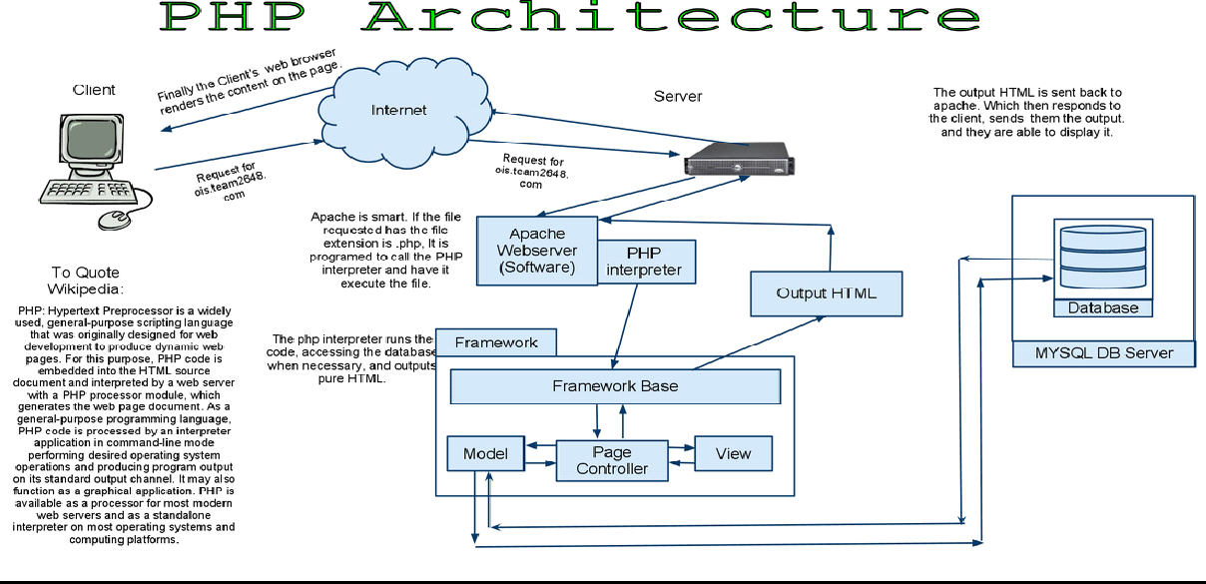

- Architecture and Concepts
The query cache plugin is implemented as a PHP extension. It is written in C and operates under the hood of PHP. During the startup of the PHP interpreter, it gets registered as a mysqlnd plugin to replace selected mysqlnd C methods. Hereby, it can change the behaviour of any PHP MySQL extension (mysqli, PDO_MYSQL, mysql) compiled to use the mysqlnd library without changing the extensions API. This makes the plugin compatible with each and every PHP MySQL application. Because existing APIs are not changed, it is almost transparent to use. Please, see the mysqlnd plugin API description for a discussion of the advantages of the plugin architecture and a comparison with proxy based solutions.

- Transparent to use
At PHP run time PECL/mysqlnd_qc can proxy queries send from PHP (mysqlnd) to the MySQL server. It then inspects the statement string to find whether it shall cache its results. If so, result set is cached using a storage handler and further executions of the statement are served from the cache for a user-defined period. The Time to Live (TTL) of the cache entry can either be set globally or on a per statement basis.
A statement is either cached if the plugin is instructed to cache all statements globally using a or, if the query string starts with the SQL hint (/*qc=on*/). The plugin is capable of caching any query issued by calling appropriate API calls of any of the existing PHP MySQL extensions.

- Flexible storage: various storage handler
Various storage handler are supported to offer different scopes for cache entries. Different scopes allow for different degrees in sharing cache entries among clients.

- default (built-in): process memory, scope: process, one or more web requests depending on PHP deployment model used
- APC: shared memory, scope: single server, multiple web requests
- SQLite: memory or file, scope: single server, multiple web requests
- MEMCACHE: main memory, scope: single or multiple server, multiple web requests
- user (built-in): user-defined - any, scope: user-defined – any
Support for the APC, SQLite and MEMCACHE storage handler has to be enabled at compile time. The default and user handler are built-in. It is possible to switch between compiled-in storage handlers on a per query basis at run time.

- Built-in slam defense to avoid overloading
To avoid overload situations the cache plugin has a built-in slam defense mechanism. If a popular cache entries expires many clients using the cache entries will try to refresh the cache entry. For the duration of the refresh many clients may access the database server concurrently. In the worst case, the database server becomes overloaded and it takes more and more time to refresh the cache entry, which in turn lets more and more clients try to refresh the cache entry. To prevent this from happening the plugin has a slam defense mechanism. If slam defense is enabled and the plugin detects an expired cache entry it extends the life time of the cache entry before it refreshes the cache entry. This way other concurrent accesses to the expired cache entry are still served from the cache for a certain time.The other concurrent accesses to not trigger a concurrent refresh. Ideally, the cache entry gets refreshed by the client which extended the cache entries lifespan before other clients try to refresh the cache and potentially cause an overload situation.

- Unique approach to caching
PECL/mysqlnd_qc has a unique approach to caching result sets that is superior to application based cache solutions. Application based solutions first fetch a result set into PHP variables. Then, the PHP variables are serialized for storage in a persistent cache, and then unserialized when fetching. The mysqlnd query cache stores the raw wire protocol data sent from MySQL to PHP in its cache and replays it, if still valid, on a cache hit. This way, it saves an extra serialization step for a cache put that all application based solutions have to do. It can store the raw wire protocol data in the cache without having to serialize into a PHP variable first and deserializing the PHP variable for storing in the cache

PHP: FRONT END
PHP is a popular general-purpose scripting language that is especially suited to web development. It was originally created by Rasmus Lerdorf in 1994; the PHP reference implementation is now produced by The PHP Group. PHP originally stood for Personal Home Page, but it now stands for the recursive initialism PHP: Hypertext Preprocessor.
PHP code is usually processed on a web server by a PHP interpreter implemented as a module, a daemon or as a Common Gateway Interface (CGI) executable. On a web server, the result of the interpreted and executed PHP code — which may be any type of data, such as generated HTML or binary image data — would form the whole or part of a HTTP response. Various web template systems, web content management systems, and web frameworks exist which can be employed to orchestrate or facilitate the generation of that response. Additionally, PHP can be used for many programming tasks outside of the web context, such as standalone graphical applications and robotic drone control. Arbitrary PHP code can also be interpreted and executed via command line interface (CLI).

The standard PHP interpreter, powered by the Zend Engine, is free software released under the PHP License. PHP has been widely ported and can be deployed on most web servers on almost every operating system and platform, free of charge.
The PHP language evolved without a written formal specification or standard until 2014, with the original implementation acting as the de facto standard which other implementations aimed to follow. Since 2014, work has gone on to create a formal PHP specification.
As of February 2020, over half of sites on the web using PHP are still on discontinued/"EOLed" version 5.6 or older and over 55% of all websites in the world run versions prior to 7.2, that are neither officially supported by The PHP Development Team, while security support is provided by third parties, such as Debian (up to June 2020 for PHP 5). PHP 7 presented an opportunity for other improvements beyond php that require backward-compatibility breaks. In particular, it involved the following changes:

Many fatal- or recoverable-level legacy PHP error mechanisms were replaced with modern object-oriented exceptions[55]
The syntax for variable dereferencing was reworked to be internally more consistent and complete, allowing the use of the operators ->, [], (),{}, and ::, with arbitrary meaningful left-side expressions
- Support for legacy PHP 4-style constructor methods was deprecated
- The behavior of the for each statement was changed to be more predictable
- Constructors for the few classes built-in to PHP which returned null upon failure were changed to throw an exception instead, for consistency
- Several unmaintained or deprecated server application programming interfaces (SAPIs) and extensions were removed from the PHP core, most notably the legacy mysql extension
- The behavior of the list() operator was changed to remove support for strings
- Support was removed for legacy ASP-style delimiters <% and %> and <script language="php"> ... </script>
- An oversight allowing a switch statement to have multiple default clauses was fixed
- Support for hexadecimal number support in some implicit conversions from strings to number types was removed
- The left-shift and right-shift operators were changed to behave more consistently across platforms
- Conversions between integers and floating point numbers were tightened and implemented more consistently across platforms
- PHP 7 also included new language features. Most notably, it introduces return type declarations for functions which complement the existing parameter type declarations, and support for the scalar types (integer, float, string, and boolean) in parameter and return type declarations.
MYSQL: BACKEND
MySQL is an open-source relational database management system (RDBMS).[6] Its name is a combination of "My", the name of co-founder Michael Widenius's daughter,[7] and "SQL", the abbreviation for Structured Query Language. MySQL is free and open-source software under the terms of the GNU General Public License, and is also available under a variety of proprietary licenses. MySQL was owned and sponsored by the Swedish company MySQL AB, which was bought by Sun Microsystems (now Oracle Corporation).[8] In 2010, when Oracle acquired Sun, Widenius forked the open-source MySQL project to create MariaDB.

MySQL is a component of the LAMP web application software stack (and others), which is an acronym for Linux, Apache, MySQL, Perl/PHP/Python. MySQL is used by many database-driven web applications, including Drupal, Joomla, phpBB, and WordPress.
MySQL is written in C and C++. Its SQL parser is written in yacc, but it uses a home-brewed lexical analyzer.[15] MySQL works on many system platforms, including AIX, BSDi, FreeBSD, HP-UX, eComStation, i5/OS, IRIX, Linux, macOS, Microsoft Windows, NetBSD, Novell NetWare, OpenBSD, OpenSolaris, OS/2 Warp, QNX, Oracle Solaris, Symbian, SunOS, SCO OpenServer, SCO UnixWare, Sanos and Tru64. A port of MySQL to OpenVMS also exists.[16]
The MySQL server software itself and the client libraries use dual-licensing distribution. They are offered under GPL version 2, or a proprietary license.
Support can be obtained from the official manual. Free support additionally is available in different IRC channels and forums. Oracle offers paid support via its MySQL Enterprise products. They differ in the scope of services and in price. Additionally, a number of third party organisations exist to provide support and services, including MariaDB and Percona.
MySQL has received positive reviews, and reviewers noticed it "performs extremely well in the average case" and that the "developer interfaces are there, and the documentation (not to mention feedback in the real world via Web sites and the like) is very, very good". It has also been tested to be a "fast, stable and true multi-user, multi-threaded sql database server.

XAMPP TUTORIAL
XAMPP is one of the widely used cross-platform web servers, which helps developers to create and test their programs on a local webserver. It was developed by the Apache Friends, and its native source code can be revised or modified by the audience. It consists of Apache HTTP Server, MariaDB, and interpreter for the different programming languages like PHP and Perl. It is available in 11 languages and supported by different platforms such as the IA-32 package of Windows & x64 package of macOS and Linux.

What is XAMPP?
XAMPP is an abbreviation where X stands for Cross-Platform, A stands for Apache, M stands for MYSQL, and the Ps stand for PHP and Perl, respectively. It is an open-source package of web solutions that includes Apache distribution for many servers and command-line executables along with modules such as Apache server, MariaDB, PHP, and Perl.
XAMPP helps a local host or server to test its website and clients via computers and laptops before releasing it to the main server. It is a platform that furnishes a suitable environment to test and verify the working of projects based on Apache, Perl, MySQL database, and PHP through the system of the host itself. Among these technologies, Perl is a programming language used for web development, PHP is a backend scripting language, and MariaDB is the most vividly used database developed by MySQL. The detailed description of these components is given below.

Components of XAMPP
As defined earlier, XAMPP is used to symbolize the classification of solutions for different technologies. It provides a base for testing of projects based on different technologies through a personal server. XAMPP is an abbreviated form of each alphabet representing each of its major components. This collection of software contains a web server named Apache, a database management system named MariaDB and scripting/ programming languages such as PHP and Perl. X denotes Cross-platform, which means that it can work on different platforms such as Windows, Linux, and macOS.
Many other components are also part of this collection of software and are explained below.
- Cross-Platform: Different local systems have different configurations of operating systems installed in it. The component of cross-platform has been included to increase the utility and audience for this package of Apache distributions. It supports various platforms such as packages of Windows, Linus, and MAC OS.
- Apache: It is an HTTP a cross-platform web server. It is used worldwide for delivering web content. The server application has made free for installation and used for the community of developers under the aegis of Apache Software Foundation. The remote server of Apache delivers the requested files, images, and other documents to the user.
- MariaDB: Originally, MySQL DBMS was a part of XAMPP, but now it has been replaced by MariaDB. It is one of the most widely used relational DBMS, developed by MySQL. It offers online services of data storage, manipulation, retrieval, arrangement, and deletion.
- PHP: It is the backend scripting language primarily used for web development. PHP allows users to create dynamic websites and applications. It can be installed on every platform and supports a variety of database management systems. It was implemented using C language. PHP stands for Hypertext Processor. It is said to be derived from Personal Home Page tools, which explains its simplicity and functionality.
- Perl: It is a combination of two high-level dynamic languages, namely Perl 5 and Perl 6. Perl can be applied for finding solutions for problems based on system administration, web development, and networking. Perl allows its users to program dynamic web applications. It is very flexible and robust.
- phpMyAdmin: It is a tool used for dealing with MariaDB. Its version 4.0.4 is currently being used in XAMPP. Administration of DBMS is its main role.
- OpenSSL: It is the open-source implementation of the Secure Socket Layer Protocol and Transport Layer Protocol. Presently version 0.9.8 is a part of XAMPP.
- XAMPP Control Panel: It is a panel that helps to operate and regulate upon other components of the XAMPP. Version 3.2.1 is the most recent update. A detailed description of the control panel will be done in the next section of the tutorial.
- Webalizer: It is a Web Analytics software solution used for User logs and provide details about the usage.
- Mercury: It is a mail transport system, and its latest version is 4.62. It is a mail server, which helps to manage the mails across the web.
- Tomcat: Version 7.0.42 is currently being used in XAMPP. It is a servlet based on JAVA to provide JAVA functionalities.
- Filezilla: It is a File Transfer Protocol Server, which supports and eases the transfer operations performed on files. Its recently updated version is 0.9.41.

XAMPP Format Support
XAMPP is supported in three file formats:
- .EXE- It is an extension used to denote executable files making it accessible to install because an executable file can run on a computer as any normal program.
- .7z - 7zip file- This extension is used to denote compressed files that support multiple data compression and encryption algorithms. It is more favored by a formalist, although it requires working with more complex files.
- .ZIP- This extension supports lossless compression of files. A Zipped file may contain multiple compressed files. The Deflate algorithm is mainly used for compression of files supported by this format. The .ZIP files are quite tricky to install as compared to .EXE
MYSQL – BACK END
The MySQL Reference Manual covers most areas of MySQL use. This manual is for both MySQL Community Server and MySQL Enterprise Server. If you cannot find the answer(s) from the manual, you can get support by purchasing MySQL Enterprise, which provides comprehensive support and services. MySQL Enterprise also provides a comprehensive knowledge base library that includes hundreds of technical articles resolving difficult problems on popular database topics such as performance, replication, and migration.
MySQL AB develops and supports a family of high-performance, affordable database products. The company's flagship offering is 'MySQL Enterprise', a comprehensive set of production-tested software, proactive monitoring tools, and premium support services. MySQL is the world's most popular open source database software. Many of the world's largest and fastest-growing organizations use MySQL to save time and money powering their high-volume Web sites, business-critical systems and packaged software -- including industry leaders such as Yahoo!, Alcatel-Lucent, Google, Nokia, YouTube and Booking.com. With headquarters in the United States and Sweden -- and operations around the world -- MySQL AB supports both open source values and corporate customers' needs.
JDBC
Java Database Connectivity (JDBC) is a programming framework for Java developers writing programs that access information stored in databases, spreadsheets, and flat files. JDBC is commonly used to connect a user program to a "behind the scenes" database, regardless of what database management software is used to control the database. In this way, JDBC is cross-platform . This article will provide an introduction and sample code that demonstrates database access from Java programs that use the classes of the JDBC API, which is available for free download from Sun's site .
A database that another program links to is called a data source. Many data sources, including products produced by Microsoft and Oracle, already use a standard called Open Database Connectivity (ODBC). Many legacy C and Perl programs use ODBC to connect to data sources. ODBC consolidated much of the commonality between database management systems. JDBC builds on this feature, and increases the level of abstraction. JDBC-ODBC bridges have been created to allow Java programs to connect to ODBC-enabled database software .
Application Areas of JDBC
JDBC has been designed and implemented for use in connecting to databases. Fortunately, JDBC has made no restrictions, over and above the standard Java security mechanisms, for complete systems. To this end, a number of overall system configurations are feasible for accessing databases.
- Java application which accesses local database
- Java applet accesses server-based database
- Database access from an applet via a stepping stone
Using a JDBC driver
JavaSoft has defined the following driver categorization system:
Type 1
These drivers use a bridging technology to access a database. The JDBC-ODBC bridge that comes with the JDK 1.1 is a good example of this kind of driver. It provides a gateway to the ODBC API. Implementations of that API in turn do the actual database access. Bridge solutions generally require software to be installed on client systems, meaning that they are not good solutions for applications that do not allow you to install software on the client.
Type 2
The type 2 drivers are native API drivers. This means that the driver contains Java code that calls native C or C++ methods provided by the individual database vendors that perform the database access. Again, this solution requires software on the client system.
Type 3
Type 3 drivers provide a client with a generic network API that is then translated into database specific access at the server level. In other words, the JDBC driver on the client uses sockets to call a middleware application on the server that translates the client requests into an API specific to the desired driver. As it turns out, this kind of driver is extremely flexible since it requires no code installed on the client and a single driver can actually provide access to multiple databases.
Type 4
Using network protocols built into the database engine, type 4 drivers talk directly to the database using Java sockets. This is the most direct pure Java solution. In nearly every case, this type of driver will come only from the database vendor.
Regardless of data source location, platform, or driver (Oracle, Microsoft, etc.), JDBC makes connecting to a data source less difficult by providing a collection of classes that abstract details of the database interaction. Software engineering with JDBC is also conducive to module reuse. Programs can easily be ported to a different infrastructure for which you have data stored (whatever platform you choose to use in the future) with only a driver substitution. To begin connecting to a data source, you first need to instantiate an object of your JDBC driver. This essentially requires only one line of code, a command to the DriverManager, telling the Java Virtual Machine to load the bytecode of your driver into memory, where its methods will be available to your program. The String parameter below is the fully qualified class name of the driver you are using for your platform combination:
Class.forName("org.gjt.mm.mysql.Driver").newInstance();

Connecting to a database
In order to connect to a database, you need to perform some initialization first. Your JDBC driver has to be loaded by the Java Virtual Machine classloader, and your application needs to check to see that the driver was successfully loaded. We'll be using the ODBC bridge driver, but if your database vendor supplies a JDBC driver, feel free to use it instead. To load the JdbcOdbcDriver class, and then catch the ClassNotFoundException if it is thrown. This is important, because the application might be run on a non-Sun virtual machine that doesn't include the ODBC bridge, such as Microsoft's JVM. If this occurs, the driver won't be installed, and our application should exit gracefully. Once our driver is loaded, we can connect to the database. We'll connect via the driver manager class, which selects the appropriate driver for the database we specify.
SYSTEM STUDY
FEASIBILITY STUDY
The feasibility of the project is analyzed in this phase and business proposal is put forth with a very general plan for the project and some cost estimates. During system analysis the feasibility study of the proposed system is to be carried out. This is to ensure that the proposed system is not a burden to the company. For feasibility analysis, some understanding of the major requirements for the system is essential.

Three key considerations involved in the feasibility analysis are
- ECONOMICAL FEASIBILITY
- TECHNICAL FEASIBILITY
- SOCIAL FEASIBILITY
ECONOMICAL FEASIBILITY
This study is carried out to check the economic impact that the system will have on the organization. The amount of fund that the company can pour into the research and development of the system is limited. The expenditures must be justified. Thus the developed system as well within the budget and this was achieved because most of the technologies used are freely available. Only the customized products had to be purchased.

TECHNICAL FEASIBILITY
This study is carried out to check the technical feasibility, that is, the technical requirements of the system. Any system developed must not have a high demand on the available technical resources. This will lead to high demands on the available technical resources. This will lead to high demands being placed on the client. The developed system must have a modest requirement, as only minimal or null changes are required for implementing this system.
SOCIAL FEASIBILITY
The aspect of study is to check the level of acceptance of the system by the user. This includes the process of training the user to use the system efficiently. The user must not feel threatened by the system, instead must accept it as a necessity. The level of acceptance by the users solely depends on the methods that are employed to educate the user about the system and to make him familiar with it. His level of confidence must be raised so that he is also able to make some constructive criticism, which is welcomed, as he is the final user of the system.
7.2 SYSTEM TESTING
The purpose of testing is to discover errors. Testing is the process of trying to discover every conceivable fault or weakness in a work product. It provides a way to check the functionality of components, sub-assemblies, assemblies and/or a finished product It is the process of exercising software with the intent of ensuring that the Software system meets its requirements and user expectations and does not fail in an unacceptable manner. There are various types of test. Each test type addresses a specific testing requirement.

TYPES OF TESTS

Unit testing
Unit testing involves the design of test cases that validate that the internal program logic is functioning properly, and that program inputs produce valid outputs. All decision branches and internal code flow should be validated. It is the testing of individual software units of the application .it is done after the completion of an individual unit before integration. This is a structural testing, that relies on knowledge of its construction and is invasive. Unit tests perform basic tests at component level and test a specific business process, application, and/or system configuration. Unit tests ensure that each unique path of a business process performs accurately to the documented specifications and contains clearly defined inputs and expected results.

Integration testing
Integration tests are designed to test integrated software components to determine if they actually run as one program. Testing is event driven and is more concerned with the basic outcome of screens or fields. Integration tests demonstrate that although the components were individually satisfaction, as shown by successfully unit testing, the combination of components is correct and consistent. Integration testing is specifically aimed at exposing the problems that arise from the combination of components.

Functional test

Functional tests provide systematic demonstrations that functions tested are available as specified by the business and technical requirements, system documentation, and user manuals.
Functional testing is centered on the following items:
Valid Input : identified classes of valid input must be accepted.
Invalid Input : identified classes of invalid input must be rejected.
Functions : identified functions must be exercised.
Output : identified classes of application outputs must be exercised.
Systems/Procedures: interfacing systems or procedures must be invoked.
Organization and preparation of functional tests is focused on requirements, key functions, or special test cases. In addition, systematic coverage pertaining to identify Business process flows; data fields, predefined processes, and successive processes must be considered for testing. Before functional testing is complete, additional tests are identified and the effective value of current tests is determined.

System Test
System testing ensures that the entire integrated software system meets requirements. It tests a configuration to ensure known and predictable results. An example of system testing is the configuration oriented system integration test. System testing is based on process descriptions and flows, emphasizing pre-driven process links and integration points.

White Box Testing
White Box Testing is a testing in which in which the software tester has knowledge of the inner workings, structure and language of the software, or at least its purpose. It is purpose. It is used to test areas that cannot be reached from a black box level
Black Box Testing

Black Box Testing is testing the software without any knowledge of the inner workings, structure or language of the module being tested. Black box tests, as most other kinds of tests, must be written from a definitive source document, such as specification or requirements document, such as specification or requirements document. It is a testing in which the software under test is treated, as a black box .you cannot “see” into it. The test provides inputs and responds to outputs without considering how the software works.
VERIFICATION
UNIT TESTING:
Unit testing is usually conducted as part of a combined code and unit test phase of the software lifecycle, although it is not uncommon for coding and unit testing to be conducted as two distinct phases.

Test strategy and approach
Field testing will be performed manually and functional tests will be written in detail.

Test objectives
- All field entries must work properly.
- Pages must be activated from the identified link.
- The entry screen, messages and responses must not be delayed.
Features to be tested
- Verify that the entries are of the correct format
- No duplicate entries should be allowed
- All links should take the user to the correct page.

INTEGRATION TESTING
Software integration testing is the incremental integration testing of two or more integrated software components on a single platform to produce failures caused by interface defects.
The task of the integration test is to check that components or software applications, e.g. components in a software system or – one step up – software applications at the company level – interact without error.
Test Results: All the test cases mentioned above passed successfully. No defects encountered.

ACCEPTANCE TESTING
User Acceptance Testing is a critical phase of any project and requires significant participation by the end user. It also ensures that the system meets the functional requirements.

Test Results: All the test cases mentioned above passed successfully. No defects encountered.
Table Name:
Field Name | Data type | Size
Username | Varchar | 50
Password | Varchar | 50

Table Name: USER REISTRATION
Field Name | Data type | Size
Userid | Int | 50
Username | Varchar | 50
Password | Varchar | 50
Address | Varchar | 50
Mobile | Int | 50
Place | Varchar | 100
Emailed | Varchar | 50
Table Name: ADMINLOGIN
Field Name | Data type | Size
Admin name | Varchar | 50
Password | Varchar | 50

Table Name: View User List
Field Name | Data type | Size
Username | Varchar | 50
Mobile Number | Varchar | 50

Conclusion:
The Event Management System provides a comprehensive and efficient platform for organizing, managing, and executing various types of events with minimal manual effort. By integrating automation and web-based technologies, the system streamlines event operations—from registration and scheduling to resource allocation and feedback collection. This not only minimizes human errors but also ensures better coordination among organizers, vendors, and participants.
The system’s user-friendly interface, real-time updates, and data-driven insights contribute to improved decision-making and enhanced participant engagement. Its modular and scalable architecture allows it to adapt to different event types and sizes, making it a valuable tool for institutions, organizations, and event planners. Overall, the Event Management System significantly improves productivity, reduces administrative workload, and delivers a seamless event experience for all stakeholders involved.

Future Scope of the Project
The future scope of the Event Management System is vast, with opportunities to integrate emerging technologies and expand its functionality. One of the major advancements will be the integration of Artificial Intelligence (AI) and Machine Learning (ML) to provide personalized event recommendations, automate attendee engagement through AI-driven chatbots, and enhance analytics for event organizers. Blockchain technology can be incorporated to enable secure and tamper-proof ticketing systems, preventing fraud and unauthorized ticket sales. The adoption of Augmented Reality (AR) and Virtual Reality (VR) will revolutionize virtual and hybrid events, allowing attendees to participate in immersive event experiences from anywhere in the world. The system can also integrate voice-enabled AI assistants, enabling hands-free event management and accessibility for people with disabilities. IoT-based smart event management can be explored to enhance venue monitoring, optimize seating arrangements, and track attendee movement for better crowd management. Another future enhancement is the development of Progressive Web Applications (PWAs), ensuring seamless access even in low-connectivity environments. Integration with social media analytics can provide event organizers with insights into audience engagement, helping them refine marketing strategies and maximize attendance. The adoption of a multi-language interface will increase global accessibility, allowing users from different linguistic backgrounds to interact with the system effortlessly. Additionally, dynamic pricing models for ticketing, powered by AI, can optimize revenue generation for organizers based on demand and market trends. As technology continues to evolve, the Event Management System will continue to expand, offering enhanced automation, better user engagement, and innovative solutions to make event planning more efficient and intelligent.

References
[1] S. K. Singh, “Design and Implementation of an Online Event Management System,” International Journal of Computer Applications, vol. 180, no. 21, pp. 10–15, 2018.
[2] M. A. Rahman and N. H. Chowdhury, “Web-Based Event Management System Using PHP and MySQL,” International Journal of Advanced Research in Computer and Communication Engineering, vol. 7, no. 4, pp. 55–59, 2019.
[3] P. Sharma and R. Kumar, “Automation of Event Scheduling and Management Using Web Application,” International Journal of Engineering Research & Technology (IJERT), vol. 9, no. 6, pp. 1120–1124, 2020.
[4] A. Gupta, S. Mehta, and V. Sharma, “Smart Event Management System Using Modern Web Frameworks,” International Journal of Innovative Research in Computer and Communication Engineering, vol. 8, no. 3, pp. 1500–1506, 2021.
[5] S. R. Patel and D. Joshi, “A Study on Automation in Event Management Systems,” International Journal of Recent Technology and Engineering (IJRTE), vol. 10, no. 2, pp. 210–215, 2022.

